**Module 2:**

1. . Write a program to make a square and cube of number.

#include <stdio.h>

int main() {

float number, square, cube;

// Taking user input

printf("Enter a number: ");

scanf("%f", &number);

// Calculating square and cube

square = number * number;

cube = number * number * number;

// Displaying the results

printf("Square of %.2f is: %.2f\n", number, square);

printf("Cube of %.2f is: %.2f\n", number, cube);

return 0;

}

Output :

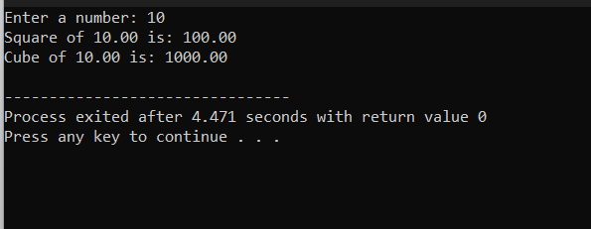

This program defines a function **square_and_cube** that takes a number as an argument and returns the square and cube of that number. Then it takes user input, calculates the square and cube using the defined function, and prints the results.

1. **Write a program to find the simple Interest & Compound Interest**

#include <stdio.h>

#include <math.h>

float simpleInterest(float principal, float rate, float time) {

// Simple Interest formula: SI = P * R * T / 100

return (principal * rate * time) / 100;

}

float compoundInterest(float principal, float rate, float time) {

// Compound Interest formula: CI = P * (1 + R/100)^T - P

return principal * (pow(1 + rate / 100, time)) - principal;

}

int main() {

float principal_amount, interest_rate, time_period, simple, compound;

// Taking user input

printf("Enter the principal amount: ");

scanf("%f", &principal_amount);

printf("Enter the interest rate: ");

scanf("%f", &interest_rate);

printf("Enter the time period (in years): ");

scanf("%f", &time_period);

// Calculating both Simple Interest and Compound Interest

simple = simpleInterest(principal_amount, interest_rate, time_period);

compound = compoundInterest(principal_amount, interest_rate, time_period);

// Displaying the results

printf("Simple Interest: %.2f\n", simple);

printf("Compound Interest: %.2f\n", compound);

return 0;

**out put :**

